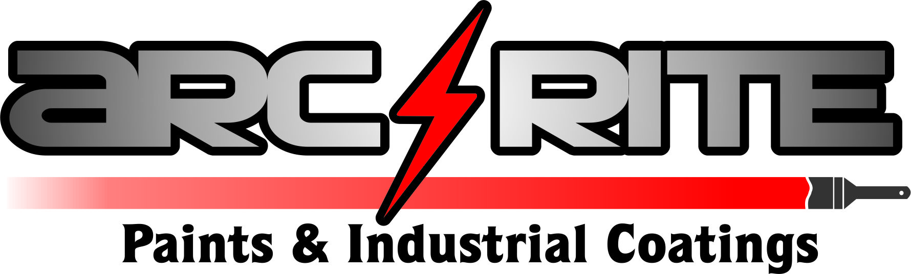

COLD GALVANISING ZINC RICH PRIMER
TECHNICAL DATA SHEET
DESCRIPTION
Arc-rite Paints Cold Galvanising Zinc Rich Primer Finish contains a pure zinc pigment, and has excellent anti - corrosive properties for ferrous metal and contains over 90% metallic zinc in the dried film.
USES
Cold Galvanising Zinc Rich Primer can be brushed or sprayed to provide cathodic protection to ferrous metal surfaces. To provide a galvanic protection on iron and steel.
It can be used as a self finish coating or as a durable rust inhibiting primer beneath selected Arc-Rite top coats. It is recommended for the protection of structural steelwork, agricultural and construction plant and machinery, gates, railings, iron pipe work and guttering, and the rust prevention of in-situ welding work.
PROPERTIES
Volume solids: 40%
Solids by weight: 80%
Zinc content by volume on dry film: 60%
Zinc content by weight on dry film: 90%
Coverage: 16 m2 / litre when used as a primer 8 m2 / litre when used as a self-finish
Drying times at 20°C — Touch dry: 4 hours
Hard dry: 24 hours
Recoating time: Overnight
SURFACE PREPARATION
All ferrous surfaces must be clean and free from oil, grease, mill scale, rust and existing coatings. This is best achieved by grit blasting, although thorough wire brushing can be sufficient. Some rust removers based on phosphoric acid tend to leave an electrically insulating film on ferrous metals and must not be used.
MIXING & PACKAGING
The Product must be thoroughly stirred to give a uniform product prior to application. It is recommended that the contents are stirred periodically during application to avoid settlement.
Arc-Rite Zinc Rich Primer is supplied at the correct viscosity for direct application from the tin but, should it be found necessary to thin, only Arc-Rite No. 8 Thinner should be added, at a rate not exceeding 1 litre of thinners to 8 litres of paint.
APPLICATION
In order to obtain the protective properties, it is important that the correct rate of application is achieved. The minimum application temperature is 10°C. All prepared surfaces should be treated with one or more coats of Zinc Rich Primer. The material should be liberally applied without any attempt to brush or roll out. The required thickness of coating may be built up by successive applications of Zinc Rich Primer when the previous coat is completely dry
CLEANING
Clean tools with No 8 Thinner or Gunwash
HEALTH & SAFETY
It is recommended that barrier creams, gloves and protective clothing be worn when using Cold Galvanising Zinc Rich Primer. If eyes are affected wash with copious amounts of cold water and seek medical advice. For hands, wash with soap and water.

